Condition Assessment Guidelines
Assessing Physical Condition, Performance, Consequence of Failure, and Redundancy for the Metropolitan Sewer District of Greater Cincinnati

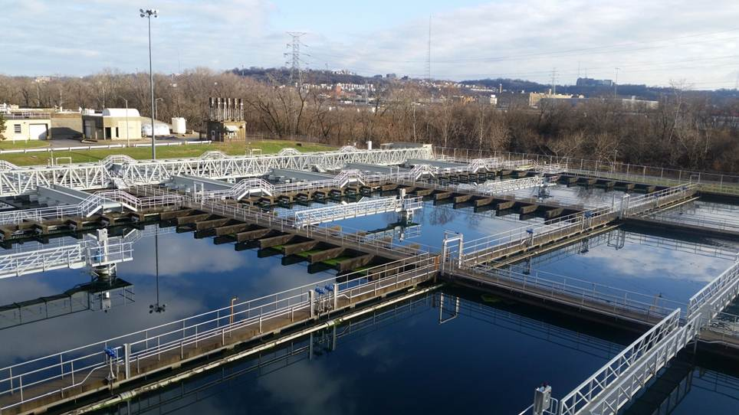

October 11, 2021

Record of Revision

Revision No. | Date | Description
0 | October 11, 2021 | Initial Issuance
1 | August 12, 2022 | Format to Revised MSD Logo and Report Template

Table of Contents
1. Purpose and Overview 1
2. Asset Definition and Hierarchy 1
2.1. Asset Definition 1
2.2. Assessment of Non-Assets 2
2.3. Asset Hierarchy 2
3. Risk Assessment 3
4. Asset Physical Condition 4
4.1. Mechanical and HVAC Assets 6
4.2. Electrical and I&C Assets 7
4.3. Structural Assets 9
5. Asset Performance Condition 10
5.1. Performance Condition Scoring Guidelines 11
5.2. Performance Condition Scoring Process 13
6. Asset Consequence of Failure and Redundancy 14
6.1. Asset Consequence of Failure 14
6.2. Asset Redundancy 17
7. Assessment Tools 17
7.1. Physical Condition Assessment 17
7.2. Performance Condition and Consequence of Failure Assessment Form 17
8. Asset Risk 18
8.1. Asset Risk 18
8.2. Risk Calculation Example 19

Tables and Figures
Table 1: Non-Assets 2
Table 2: Maximo Asset Hierarchy Levels 3
Table 3: AMS Asset Hierarchy Levels 3
Table 4: Asset Types not being Assessed 4
Table 5: Summary of Physical Condition Scores 5
Table 6: Summary of Mechanical and HVAC Physical Condition Scores 6
Table 7: Summary of Electrical Physical Condition Scores 8
Table 8: Summary of Structural Physical Condition Scores 9
Table 9: Summary of Performance Condition Scores 11
Table 10: Summary of Performance Condition Scores 11
Table 11: Summary of Performance Condition Criteria and Possible Data Sources 12
Table 12: Process Level Criteria Discussion Points 13
Table 13: Group Level Criteria Discussion Points 13
Table 14: Summary of COF Evaluation Criteria and Scores 15
Table 15: Summary of COF Evaluation Criteria and Scores for the Economic Category 16
Table 16: Summary of COF Evaluation Criteria and Scores for the Social Category 16
Table 17: Summary of COF Evaluation Criteria and Scores for the Environmental Category 16
Table 18: Risk Calculation Example 19

Figure 1: Sample System 5
Figure 2: Performance and COF Assessment Form Example 18

Purpose and Overview
This document details the methodology used to determine asset condition, consequence of failure, redundancy, and risk to prioritize the capital needs and plan for the ongoing rehabilitation and replacement of assets. All assets eventually reach the end of their useful life where condition and risk of failure is unacceptable, they can no longer provide required capacity or performance, they become technically obsolete, or they become financially inefficient to operate and maintain. The frameworks employed in this document will help focus investments in asset rehabilitation and replacement.
The document is organized as follows:
Section 2 – Asset Definition and Hierarchy: Explains how MSDGC defines an asset, the asset hierarchy and hierarchical organization, as well as appropriate levels of the hierarchy where assessments are performed.
Section 3 – Risk Assessment: Defines the three risk assessment types used
Section 4 – Asset Physical Condition Assessment: Explains the guidelines for physical condition assessment, criteria, scores and assessment types.
Section 5 – Asset Performance Condition Assessment: Explains the guidelines for assessing the ability of assets to meet current and future performance criteria.
Section 6 – Asset Consequence of Failure and Redundancy: Explains the triple bottom line evaluation criteria for consequence of asset failure and the role of redundancy in mitigating risk.
Section 7 – Assessment Tools: Explains the software and forms used to document the assessment process
Section 8 – Asset Risk: Explains how condition, consequence of failure, and redundancy come together to determine the asset risk score.

Asset Definition and Hierarchy

Asset Definition
It is important for an organization to define what factors will determine asset definition. MSDGC uses the following three questions as a guide for defining assets:
- Will a work order be written to this specific item?
- Will a separate condition assessment need to be performed on this item?
- Will depreciation or costs need to be tracked separately on this item?
Based on the questions above, there are a number of items that MSDGC does not consider assets as seen in Table 1. Some of these items may represent a significant capital investment, process element, or safety precaution. These items as detailed in Section 2.2 will require an informal assessment.
Table 1: Non-Assets
Not Considered an Asset
Architectural items, Bldg. lighting & plumbing, Computer equipment, Communication equipment, Employee facilities, Fleet vehicles, Furnishings and Furniture, Laboratory equipment, Portable equipment, Spare parts, Roadways & Pavement

Assessment of Non-Assets
There are a number of items that are not considered assets, but still require their condition to be assessed:
- Pavement
- Lighting (interior and exterior), electrical wiring
- Process piping
- Utility piping (water, storm sewers, sewers, natural gas, fuel oil, etc.)
- Fire protection (includes building sprinklers, sprinkler controls and auxiliary pumping systems, yard hydrants, and sensors)
- Architectural features (windows, doors, awnings, flooring, restrooms, showers, kitchens, ADA Compliance, Security, etc.)
- Flood protection (earthen and concrete dikes, flood gates)
- Fencing
The consultant is expected to review these items and document any relevant observations.

Asset Hierarchy
Asset hierarchy is used to organize assets into an appropriate framework. This top-down structure allows technicians and engineers to understand the relationship between assets using “parent-child” logic. This supports identifying the planning and scheduling of maintenance activities and capital planning projects.
A key benefit of organizing assets into a hierarchy is that it provides for effective roll-up of cost, condition, and risk data across the complete asset portfolio. Work orders will be written at the individual asset level, whereas the higher levels are considered “virtual assets” and can be utilized for performance and cost reporting purposes.
MSDGC utilizes two systems in the risk assessment component of their assets management program; Maximo and the Asset Management system (AMS). Maximo is the CMMS system that stores asset physical condition data, redundancy data, and asset attributes. The AMS interfaces with Maximo to display asset information. It also stores performance conditions scores and consequence of failure scores. These systems utilize slightly different hierarchies, shown in the table below:

Table 2: Maximo Asset Hierarchy Levels
Level | Maximo Level Name and Description
0 | SYSTEMID (CINTI)
1 | SITEID (MSDGC)
2 | ORGID (MSD)
3 | DIVISION (i.e., WWT)
4 | SECTION (i.e., East Section)
5 | ZONE (i.e., Polk Run)
6 | PROCESS (i.e., Infrastructure, liquid process, solid process)
7 | AREA (i.e., Influent pumping, aeration process, UV disinfection)
8 | GROUP (Varies based on Area – i.e., instruments, valves, pumps)
9 | ASSET’S LOCATION
10 | ASSET

Table 3: AMS Asset Hierarchy Levels
Level | AMS Level Name and Description
1 | UTILITY (MSD)
2 | FACILITY CATEGORY (WWTP, Pump Station, Collection)
3 | FACILITY (i.e., Mill Creek, Little Miami, Auxiliary Process And Structure)
4 | PROCESS GROUP (i.e., primary treatment, disinfection)
5 | PROCESS AREA (i.e., influent pumping, aeration, settling)
6 | EQUIPMENT GROUP (i.e., PRI settling tanks, UV disinfection)
7 | ASSET

- Risk Assessment
MSDGC utilizes three different assessments in order to evaluate asset risk; Physical Condition, Performance Condition, and Consequence of Failure. Physical condition refers to the current state of repair, maintainability, operation of an asset, the deterioration (wear), and effective useful life – as influenced by age, historical maintenance, and operating environmental conditions. Performance condition assesses both (1) the current state of performance and ability to meet its current levels of service; and (2) the ability of the asset to meet future anticipated demand conditions and future levels of service. There are two components of assessing the effective useful life of an asset – physical condition and performance. Details regarding each assessment type are included in sections 4,5, and 6.
Several asset types are excluded from the visual assessment effort due to several reasons; either a visual condition assessment is not effective, they are already assessed by others due to code requirements, or they are inaccessible for visual assessment. Table 4 provides additional details on asset types that will not receive a visual assessment. While some of these assets/items may not receive a visual condition assessment they may be still be subject to performance assessments or Consequence of failure assessments.
Table 4: Asset Types not being Assessed
Reason for no visual risk assessment performed | Asset Types involved
Visual Condition Assessment Ineffective | Analyzer
Inaccessible for assessment | Underground & Buried items, Submersible equipment
Assessed by code | Cranes, Elevators, Fire, Safety & Security, Backflow Preventers

For assets that require a confined space entry to perform the visual assessment, the consultant is required to submit a confined space entry plan and qualifications of the personnel entering the confined space.
- Asset Physical Condition
Physical Condition assessments on MSDGC assets take place on two levels: Asset-level and Component-level defined as such:
Asset Level Assessments – An existing asset record from Maximo is used and the asset is given scores in multiple criteria. Examples of individual assets which would receive an asset level assessment include:
- Valves = > 14”, and all actuated valves
- Motors/Drives > 7.5 hp
- Pumps, process equipment
- Buildings, tanks, process structures
- Remote Programmable Logic Controller (PLC) or Control Panels (typically located in control room)
- Instrumentation estimated at over $5,000 excluding
  - Analyzers
Component Level Assessments- The assessment is part of the criteria for the asset and the component is given one overall score. Common examples of components and their associated assets include:
- Motor Control Center (MCC)cubicles are assessed as part of the MCC asset
- Actuators are assessed as part of the gate or valve
- Local control panels/Instruments are assessed as part of the tank or equipment
Consider the two-tank, three-pump system shown below, with typical piping, valves, local control panel, and instrumentation in place. If we assume the motors are 125 hp each, and the valves are less than 14”, then asset level assessments would only be performed on the two tanks, the three motors, and the three pumps – the associated valves, instrumentation, and local control panel will be considered components of each pump.
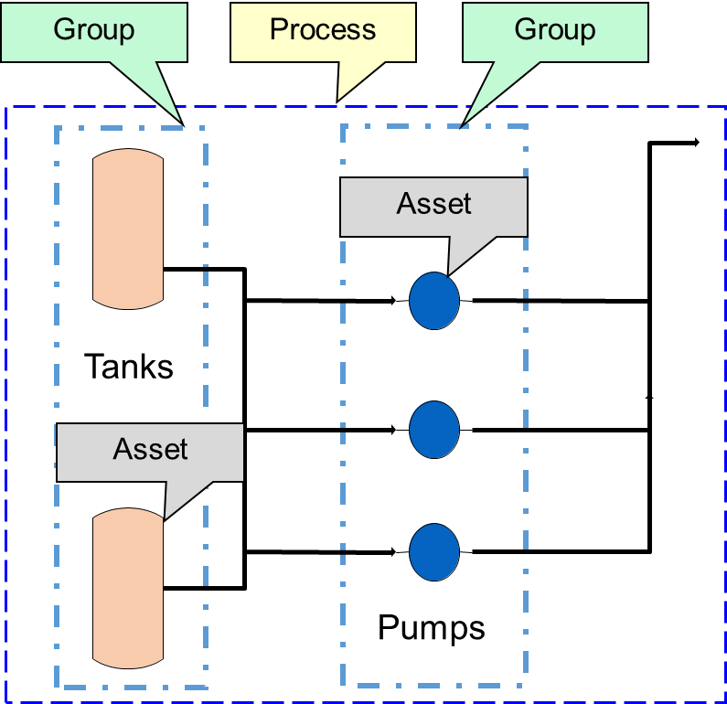
Figure 1: Sample System
Asset condition is evaluated using a 1 to 5 scale (1 – excellent and 5 – very poor), which results in a comparative score and ranking. The overall condition score of an asset is the maximum of the core physical condition and performance assessment criteria.
Table 5: Summary of Physical Condition Scores
Score | Description of Physical Condition
0--Not scored | Asset was in accessible during the time of the visual condition assessment.
1 – Excellent | Fully operable, well maintained, and consistent with current standards. Little wear shown and no further action required.
2 – Good | Sound and well maintained but may be showing slight signs of early wear. Delivering full efficiency with little or no performance deterioration. Only minor renewal or rehabilitation may be needed in the near term.
3 – Moderate | Functionally sound and acceptable and showing normal signs of wear. May have minor failures or diminished efficiency with some performance deterioration or increase in maintenance cost. Moderate renewal or rehabilitation needed in near term.
4 – Poor | Functions but requires a high level of maintenance to remain operational. Shows abnormal wear and is likely to cause significant performance deterioration in the near term. Replacement or major rehabilitation needed in the near term.
5 – Very Poor | Effective life exceeded and/or excessive maintenance cost incurred. A high risk of breakdown or imminent failure with serious impact on performance. No additional life expectancy with immediate replacement needed.

Assets are organized into three different assessment types for condition assessment: Mechanical/HVAC, Electrical/I&C, and Structural. Physical condition is evaluated through visual inspection and utilizing physical condition scoring criteria defined for each assessment type. Each assessment type includes core and ancillary criteria as follows:
- Mechanical/HVAC criteria include:
  - Core – Corrosion, Leakage, Vibration, Supports
  - Ancillary – Piping/Valves, Local Control Panels, Field Instruments, and Electrical Connections.
- Electrical/I&C criteria include:
  - Core – Corrosion, Dielectric Leakage, Vibration/Noise, Electrical Damage
  - Ancillary – Concrete and Steel Supports.
- Structural criteria include:
  - Core – Leakage, Concrete/Masonry Damage, Steel Damage, Wood Damage, Water/Drainage, Roof/Cover
  - Ancillary – Walkways/ Platforms/Railings and Doors/Hatches/Windows.
The highest score from the core criteria will carry forward to the risk calculation; whereas the ancillary criteria scores will not be factored into risk analysis. Ancillary scores will, however, be available for reporting. The specific standard criteria sheets for each assessment type are provided in the following sections.

Mechanical and HVAC Assets
The following table summarizes the criteria and scoring approach for visual condition assessment for both mechanical and HVAC assets:
Table 6: Summary of Mechanical and HVAC Physical Condition Scores
Mechanical/HVAC Equipment Visual Condition Assessment
Criteria | Evaluation | 1 | 2 | 3 | 4 | 5
CORE CRITERIA
Corrosion | Surface only | None | <10% | 10% - <25% | 25% - 50% | >50%
 | Structural (loss of metal) | None | N/A | N/A | 1 location | >1 location
Leakage | Gaskets/ Connections | None | Historic only | Drip only | Stream 1 location | Stream >1 location
 | Holes/ Failures | None | N/A | N/A | 1 location | >1 location
Vibration/ Noise | Vibration Apparent with Noise | None | <10% normal | 10% to 20% normal | >20% to 30% normal | >30% normal
 | Non-Structural Damage | None | N/A | N/A | Yes | N/A
 | Structural Damage | None | N/A | N/A | N/A | Yes
Concrete Supports | Surface Cracking/ Loose Grout | None | <10% | 10% - <25% | 25% - 50% | >50%
 | Through Cracks | None | N/A | <10% | 10% - 25% | >25%
 | Missing Pieces | None | N/A | <5% | 5% - 20% | >20%
Steel Supports | Surface Corrosion | None | <10% | 10% - <25% | 25% - 50% | >50%
 | Structural Corrosion | None | N/A | <10% | 10% -25% | >=25%
 | Damaged/ Missing Anchors | None | N/A | <5% | 5% - 20% | >=20%
ANCILLARY CRITERIA
Piping/ Valves | Leaks – gaskets | None | N/A | Drips only | Stream – 1 location | Stream - >1 location
 | Leaks – holes/ failures | None | N/A | N/A | 1 location | >1 location
 | Corrosion – surface | None | <10% | 10% - <25% | 25% - 50% | >50%
 | Corrosion – structural | None | N/A | <10% | 10% -25% | >25%
 | Support damage | None | N/A | <5% | 5% - 20% | >20%
Local Panels | Surface corrosion | None | <10% | 10% - <25% | 25% - 50% | >50%
 | Structural damage | None | N/A | N/A | 1 location | >1 location
 | Internal corrosion/ leakage | None | <10%/ none | 10% - <25%/ none | >=25%/ 1 location | >=25%/ >1 location
 | Panel Instruments – non-function | None | N/A | N/A | 1 device or 20% | >1 device or >20%
Field Instruments | Damaged/ non-functional devices | None | N/A | N/A | 1 device or 20% | >1 device or >20%
Electrical Connections | Conduit/ J. Box - surface corrosion | None | <10% | 10% - <25% | 25% - 50% | >50%
 | Damage - gaps/ missing gaskets | None | N/A | N/A | 1 location | >1 location
 | Exposed wiring | None | N/A | N/A | 1 location | >1 location

Electrical and I&C Assets
The following table summarizes the criteria and scoring approach for visual condition assessment for electrical and instrumentation & control assets:
Table 7: Summary of Electrical Physical Condition Scores
Electrical/I&C Visual Condition Assessment
Criteria | Evaluation | 1 | 2 | 3 | 4 | 5
CORE CRITERIA
Corrosion | Surface only | None | <10% | 10% - <25% | 25% - 50% | >50%
 | Structural | None | N/A | N/A | 1 location | >1 location
Dielectric Leakage | Transformer/Connection Leaks | None | Historic only | N/A | N/A | Active
 | Holes/ Failures | None | N/A | N/A | N/A | 1 location
Vibration/Noise | Vibration Apparent with Noise | None | <10% normal | 10% to 20% normal | >20% to 30% normal | >30% normal
 | Non-Structural Damage | None | N/A | N/A | Yes | N/A
 | Structural Damage | None | N/A | N/A | N/A | Yes
Electrical Damage | Evidence of Overheating/Arcing | None | N/A | N/A | 1 location | >1 location
 | Evidence of Water Damage | None | N/A | N/A | 1 location | >1 location
 | Grounding Missing/Damaged | None | N/A | N/A | 1 location | >1 location
 | Insulation Wear | None | N/A | N/A | 1 location | >1 location
 | Cooling System Damage | None | N/A | N/A | 1 location | >1 location
 | Connections Loose/Broken | None | N/A | N/A | 1 location | >1 location
 | Hot Spots | None | N/A | N/A | N/A | 1 location
 | Damaged/ Non-Functional Devices | None | N/A | 1 location | 2 locations | >2 locations
ANCILLARY CRITERIA
Concrete Supports | Surface Cracking/ Loose Grout | None | <10% | 10% - <25% | 25% - 50% | >50%
 | Through Cracks | None | N/A | <10% | 10% - 25% | >25%
 | Missing Pieces | None | N/A | <5% | 5% - 20% | >20%
Steel Supports | Surface Corrosion | None | <10% | 10% - <25% | 25% - 50% | >50%
 | Structural Corrosion | None | N/A | <10% | 10% -25% | >=25%
 | Damaged/ Missing Anchors | None | N/A | <5% | 5% - 20% | >=20%

Structural Assets
The following table summarizes the criteria and scoring approach for visual condition assessment for structural assets:
Table 8: Summary of Structural Physical Condition Scores
Structural Visual Condition Assessment
Criteria | Condition | 1 | 2 | 3 | 4 | 5
CORE CRITERIA
Leakage | Cracks/ Joints | None | Historic only | Drip only | Stream 1 location | Stream >1 location
 | Penetrations/ Failures | None | N/A | N/A | 1 location | >1 location
Concrete/ Masonry Damage | Joint Deterioration | None | <10% | 10% - <30% | 30% - 50% | >50%
 | Cracking (width of crack) | None | < 1mm | 1-2mm | >2mm | Not Serviceable
 | Exposed Reinforcement | None | N/A | N/A | 1 location | >1 location
 | Spalling, Exposed Aggregate., Pitting, Delamination, Freeze/Thaw Damage | None | N/A | <10% | 10% - 30% | >30%
Steel Damage | Surface Corrosion | None | <10% | 10% - <25% | 25% - 50% | >50%
 | Cracking | None | N/A | N/A | 1 location | >1 location
 | Fatigue/Connection Failure | None | N/A | N/A | 1 location | >1 location
 | Deformation/ Deflection | None | N/A | <5% | 5% to 10% | >10%
 | Loss of Section | None | N/A | <10% | 10% - 30% | >30%
Wood Damage | Dry Rot | None | N/A | N/A | 1 location | >1 location
 | Warping/Splitting | None | N/A | N/A | 1 location | >1 location
 | Connection Failure | None | N/A | N/A | 1 location | >1 location
 | Loss of Section | None | N/A | <10% | >10% - 30% | >30%
Water/ Drainage | Standing Water (% of foundation) | None | N/A | <=5% | >5% - 10% | >10%
Roof/ Cover1 | Leaks- Cracks/Joints | None | Historic Only | Drip Only | Stream 1 location | Stream >1 location
 | Leaks- Penetrations/Failures | None | N/A | N/A | 1 location | >1 location
 | Sagging | None | N/A | <=5% | >5% - 10% | >10%
 | Support Damage | None | N/A | N/A | <20% | >=20%
ANCILLARY CRITERIA
Walkways/ Platforms/ Railings | Surface corrosion | None | <10% | 10% - <25% | 25% - 50% | >50%
 | Structural damage | None | N/A | N/A | 1 location | >1 location
 | Loss of Section | None | N/A | <10% | >10% - 30% | >30%
 | Deformation/ Deflection | None | N/A | <=5% | >5% - 10% | >10%
Doors/ Hatches/ Windows | Leaks | None | N/A | N/A | 1 location | >1 location
 | Surface Corrosion | None | <10% | 10% - <25% | 25% - 50% | >50%
 | Structural Damage | None | N/A | N/A | N/A | >= 1 location
1: For building roofs and other membrane covered structures the consultant can review the most recent roofing report instead of conducting the visual condition assessment. If the most recent report is out of date the consultant can have a new assessment completed.

Asset Performance Condition
The performance condition captures the modes of asset failure beyond mortality, and include the following main categories:
- Capacity – Ability to meet current and future capacity
- Regulatory – Ability to meet current and future regulations and utility goals
- Availability – Average time equipment is available when needed
  - Mean time between failure (MTBF)/(MTBF+ Mean time to repair MTTR)
- Reliability – Measure of equipment uptime
  - Mean time between failure (MTBF)
- O&M Issues - Frequency of O&M Issues above and beyond regular maintenance (excluding breakdowns)
- Obsolescence - Equipment Technology, Operating Efficiency, Spare/Replacement Parts
Each criterion is considered for current conditions as well as expected future conditions. For example, expectations for changing regulations or capacity needs may affect the ability of an asset to adequately meet future operating goals, and this would be reflected in the rating. MSDGC further defined “future” capacity requirements as 20-year projections, while “future: regulatory requirements will consider the next ten years. The scores for performance condition range from 1 (excellent) to 5 (very poor), as indicated below:

Table 9: Summary of Performance Condition Scores
Score | Description of Performance Condition
1 – Excellent | Meets all capacity and regulatory requirements in all current and future anticipated demand conditions. State of the art technology with overall excellent performance.
2 – Good | Meets all capacity and regulatory requirements in current and future anticipated average conditions. May have minor risk under current peak conditions and will not meet anticipated future peak capacity conditions. Future regulatory compliance may require some modifications. Overall performance excellent to very good with tried and true technology
3 – Moderate | Current capacity is acceptable under average conditions but does not consistently meet current peak condition and would likely not meet future peak conditions. Current regulatory requirements are met, but future requirements will likely not be met, even with modifications. Overall performance and efficiency are average.
4 – Poor | Current performance is marginal and will not meet future additional requirements or increased demand (e.g. capacity, level of service goals and/or future regulatory requirements).
5 – Very Poor | Current performance unacceptable and does not meet currently required performance criteria (e.g. capacity, level of service goals and/or regulatory requirements).

Performance Condition Scoring Guidelines
The performance condition assessment includes discussions with O&M personnel and other staff to review operating history and to understand any issues unique to the equipment. Since MSDGC has a robust predictive maintenance program, including the use of BI-Cycle and Tango, these programs will be used to determine the performance condition when this data is available.
The table below indicates how performance condition is measured for each criterion.
Table 10: Summary of Performance Condition Scores
Performance Condition Assessment
Criteria | Evaluation | 1 | 2 | 3 | 4 | 5
Capacity | Ability to meet current capacity | Average – Yes  Peak – Yes | N/A | N/A | Average – Yes  Peak - No | Average – No  Peak - No
 | Ability to meet future capacity | Average – Yes  Peak – Yes | N/A | Average – Yes  Peak – No | Average – No  Peak – No | N/A
Regulatory | Ability to meet current regulations & utility goals | Average – Yes  Peak – Yes | N/A | N/A | Average – Yes  Peak - No | Average – No  Peak - No
 | Ability to meet future regulations & utility goals | Average – Yes  Peak – Yes | N/A | Average – Yes  Peak – No | Average – No  Peak – No | N/A
Availability¹ | (MTBF)/  (MTBF+ MTTR) | TBD | TBD | TBD | TBD | TBD
Reliability¹ | MTBF | TBD | TBD | TBD | TBD | TBD
O&M Issues | Frequency of O&M Issues above and beyond regular maintenance (excluding breakdowns) | None | Very Infrequently  (Quarterly) | Infrequently  (Monthly) | Frequently  (Weekly) | Very Frequently (>Weekly)
Obsolescence | Status of Equipment Technology, Operating Efficiency, Spare/Replacement Parts Availability, Energy Efficiency | Technology Best Available/ State of the Art  Or  Standard/Tried and True | N/A | Technology Nearing Obsolescence | N/A | Technology Obsolete/ Out of Date
1. Due to lack of sufficient data all equipment groups will receive a score of 1 for these criteria.
The table below provides a snapshot of possible data sources that will be used to score each criterion.
Table 11: Summary of Performance Condition Criteria and Possible Data Sources
Criteria | Mode of Failure | Description | Possible Data Sources
Capacity | Capacity | Considers current and future capacity needs | Performance Criteria Facility Plans/ Master Plan,  Asset Performance  SCADA
Regulatory | Level of Service (external) | Considers current and future regulatory requirements | Operating Reports (eOps)
Availability | Efficiency (internal KPI) |  | Advanced Maintenance (Tango, BI-Cycle) and SCADA
Reliability | Efficiency (internal KPI) |  | Advanced Maintenance (Tango, BI-Cycle) and SCADA
O&M Issues | Efficiency (internal KPI) | Additional maintenance not related to breakdowns | Advanced Maintenance (Tango, BI-Cycle) and eOps
Obsolescence | Efficiency  (internal KPI) | State of technology versus requirements | Operating Data

Performance Condition Scoring Process
Performance condition is scored through interviewing appropriate MSDGC staff regarding the performance of an asset process or group and reviewing any existing supporting data such as data from the advanced maintenance programs, as available. The discussion points presented in the table below are examples to consider when assigning performance condition scores.
Table 12: Process Level Criteria Discussion Points
Process Level Criteria: Capacity and Regulatory
Criteria | Discussion Points
Capacity | - Ability to meet current capacity  - (Average – Y/ N, Peak – Y/ N)  - Number of units in service (Average, Peak)  - Ability to meet future capacity  - (Average – Y/ N, Peak – Y/ N)  - Number of units in service (Average, Peak)  - Need for scoring at asset level  - Issues with process group due to current flows  - Capacity analysis or master planning projection needs  - Review of supporting test data
Regulatory Commitments | - Ability to meet current regulations and utility goals  - ( Y/ N/ With Some Modifications )  - Ability to meet future regulations and utility goals  - ( Y/ N/ With Some Modifications )  - Existing warning letters or consent orders  - Review of supporting test data

Table 13: Group Level Criteria Discussion Points
Group Level Criteria: Availability and Obsolescence
Criteria | Discussion Points
Availability | - Estimation of average time equipment is available when needed (including breakdowns)  - (MTBF)/ (MTBF+MTTR)  - Preliminarily assessed from CMMS? (Y or N)  - Need to request CMMS data based on discussion? (Y or N)  - Review of supporting test data
Reliability | - MTBF  - Equipment Uptime  - Review of supporting test data
O&M Issues | - Frequency and Complexity of O&M issues (excluding breakdowns)  - Rate of consumables/wear items (lubricant, gaskets, seals, etc.)
- Equipment Problems
- Plugging/Jamming/Leaking/Etc.
- Manual vs. Automatic Operation
- Availability of (and Confidence in) control and monitoring
- Operator rounds
- Continuous vs. Intermittent operation
- O&M issues with either mode
- General Operational Issues
- Operator “Workarounds”
- Modifications to improve performance
- Review of supporting test data
Obsolescence | - Availability of spare parts  - Appropriate technology, considered for new installations  - Operating efficiency  - Operator skill/training  - Average lead time for parts (from manufacturer)  - Relative cost for parts  - Additional automation or controls required  - Review of supporting test data

Asset Consequence of Failure and Redundancy

Asset Consequence of Failure
The consequence of failure analysis is based on a triple bottom line (TBL) evaluation, which considers the economic, social, and environmental consequences of a failure. Where applicable, the potential costs of failure are assigned to specific criteria within each TBL category to develop the best approximation of the overall potential cost. The following COF criteria and scoring are presented below:
Economic Consequence: The criteria and measures for evaluating direct economic impact considers repair costs and disruption to operations, including effort to repair (time, cost, and need for outside expertise) and impact to operations (loss of redundancy, impacts to upstream and/or downstream processes.)
Environmental Consequence: The criteria and measures for evaluating environmental impact consider timing and magnitude of consequence.
Social Consequence: The criteria and measures for evaluating social impact consider timing and magnitude of consequence.
Consequence of Failure Scoring uses a 1 to 5 scale, with 1 indicating “No Impact” and 5 indicating “Very High Impact.” The highest COF scores from each TBL category are averaged together to determine the overall COF score for that asset. See Table 18 for an example calculation.

Table 14: Summary of COF Evaluation Criteria and Scores
Score | Economic | Environmental | Social
1 | 1 = Minimal to No impacts | 1 = Minimal to No impact | 1 = Minimal to No impacts
2 | 2 = Low Impact/ Minor Consequence | 2 = Low impact, minor permit violations | 2 = Occasionally cannot meet requirements for customers
3 | 3 = Moderate Impact/ Moderate Consequence | 3 = Moderate impact, significant permit violations | 3 = Frequently cannot meet requirements for localized area of customer base
4 | 4 = Significant Impact/Major Consequence | 4 = Significant impact, major permit violations | 4 = Frequently cannot meet requirements for several areas of customer base
5 | 5 = Major Impact/Catastrophic Consequence | 5 = Major impact, permit violations may involve federal and state actions | 5 = Continuously cannot meet requirements for customers

The asset consequence of failure considers the impacts of asset failure using the triple bottom line (TBL) approach. Where applicable, the potential costs of failure are assigned to specific criteria within each TBL category to develop the best approximation of the overall potential cost to MSDGC. The TBL approach evaluates the economic, social and environmental impacts of asset failure.
The components of the triple bottom line are defined as follows:
Economic (generally scored at the asset level)
- Capital Cost
- O&M Impacts
Social (generally scored at the group level)
- Level of Service Delivery (loss of service, overflows, back-ups, odors)
- Health & Safety (employee and public)
Environmental (generally scored at the group level)
- Regulatory compliance (WIBs, overflow volume)
- Impacts to environmentally sensitive areas (water bodies, wetlands)
The criteria and measures within each TBL category have been developed with input from MSDGC staff.
Table 15: Summary of COF Evaluation Criteria and Scores for the Economic Category
Economic CoF Criteria and Scoring
Criteria | Measure | 1 | 2 | 3 | 4 | 5
Capital Cost | Replace Cost | <$25K | N/A | $25-<$100K | $100K-<$500K | >=$500K
O&M Impacts | Staffing and Cost Impacts | No Impacts | Low  (<=2 FTEs  for <= 1 day) | Moderate  (2+ FTEs for <=1 week) | High  (2+ FTEs for  >1 week) | Highest  (outsourced)

Table 16: Summary of COF Evaluation Criteria and Scores for the Social Category
Social COF Criteria and Scoring
Criteria | Measure | 1 | 2 | 3 | 4 | 5
Level of Service Delivery | Disruption length and magnitude | None | <1 day  Localized | >1day  Localized | <1 day  Widespread | >1day  Widespread
Health & Safety | Potential for illness or injury | No potential | Potential for minor illness or injury | Potential for moderate illness or injury | Potential for major illness or injury | Potential for fatality

Table 17: Summary of COF Evaluation Criteria and Scores for the Environmental Category
Environmental COF Criteria and Scoring
Criteria | Measure | 1 | 2 | 3 | 4 | 5
Regulatory | Permit compliance enforcement action | No compliance impact | N/A | Eventual non-compliance if no response | N/A | Immediate non-compliance
Potential for impacts to sensitive areas | Time to respond & repair | Immediate | <2 hrs | 2 to <8 hrs | 8 to <24 hrs | >24 hrs

A complete COF evaluation must also properly consider redundancy in the evaluation of failure impacts. MSDGC determined that redundancy should be calculated at the peak operating conditions for their assets.

Asset Redundancy
Redundancy is a solution to reduce the impact of an asset failure. In practice, risk mitigation can be achieved through multiple strategies including design measures such as redundancy and pump-arounds, operational measures such as diversions, heightened monitoring, targeted preventive maintenance, business continuity planning and on-site warehousing of critical equipment. Scores are assigned to indicate the amount of risk reduction achieved through the measure, with a score of 1 representing no reduction and a score of 0 representing the complete elimination of all risk.
Redundancy is evaluated at peak operating conditions. For example, if three pumps are needed to satisfy peak demand and four are installed and functional, then one quarter of the pumps can fail with minimal consequence and the risk mitigation score is reduced from 1 by one quarter. Redundancy and redundancy factor are calculated using the following using the following equation:

$$Redundancy=\frac{Number Installed-Number Needed}{Number Installed}$$
$$Redundancy Factor=1-Redundancy$$

Assessment Tools

Physical Condition Assessment
MSDGC conducts physical condition assessments on tablets equipped with the DataSplice Software. This software provides mobile friendly integration with Maximo through a user-friendly interface. This equipment as well as appropriate training documentation will be provided to the consultant for temporary use.

Performance Condition and Consequence of Failure Assessment Form
An example performance condition and Consequence of Failure assessment form is included below. These forms are generated using available information on MSDGC facilities to guide the performance assessment process. Data fields are provided to record the 1 through 5 scores at the appropriate hierarchy level for ass seen in Figure 2.
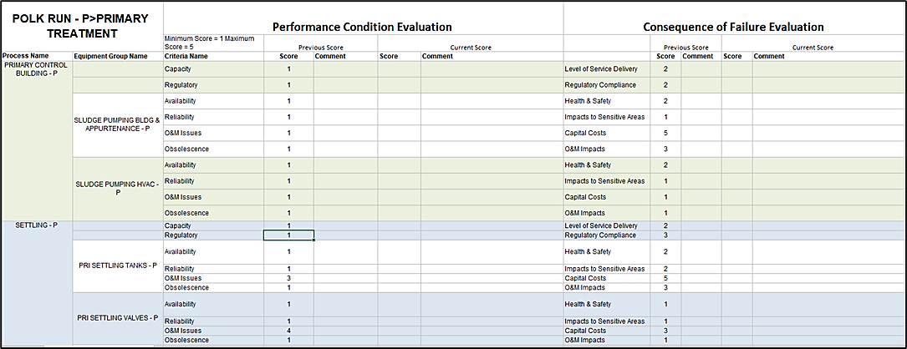
Figure 2: Performance and COF Assessment Form Example

Asset Risk

Asset Risk
MSDGC’s assets provide vital services to customers, and failure represents a unique risk to the organization from social, environmental, or financial ramifications. Through risk analysis, we can compare the relative risks embedded in the system to make better resource allocation decisions. When assets throughout the organization are scored using a consistent methodology, the risk score provides a common basis for comparison of a highly diverse collection of assets.
To calculate risk, an evaluation is performed on the physical condition and performance condition of an asset. The maximum condition criteria score is carried through as the asset’s overall condition score (on a scale from 1- excellent to 5 – very poor). Next, the average of the highest score in each TBL category is carried through for the asset’s overall COF score (on a scale from 1- minimal/no impact to 5 – high impact. Last, any operating redundancy pertaining to the asset is considered in the Redundancy Factor (on a scale from 0 to 1). The risk score is calculated using the following formula:
Risk = Likelihood of Failure x Consequence of Failure x Redundancy Factor
Where:
- LOF = the maximum score from the physical and performance condition assessment
- COF = the average of the highest score in each TBL category
- Rf = the redundancy factor
Risk will be distributed on a scale of 1 (low risk) to 25 (highest risk). Based on the risk score, assets are organized into one of five risk groupings: High (24-25), Medium High (20-23), Medium (15-19), Medium Low (10-14) and Low (<10). These risk groupings will help determine the year the asset is addressed in the capital improvement plan.

Risk Calculation Example
The following example of a pump illustrates how the risk score is calculated for an asset.
Table 18: Risk Calculation Example
Equipment | Physical Score | Performance Score |  | COF Score |  | Redundancy Factor
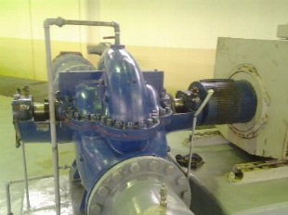  Pump | Core Criteria:  Corrosion = 2  Leakage = 2  Vibration = 1  Conc. Ped = 2  Steel Supp. = 3 | Capacity | 3 | Economic:  Capital Cost = 3  O&M Impact = 2 | 3 | 4 pumps  3 needed at peak  4-3 = 0.25  4  (1-0.25) = 0.75
 | Ancill. Criteria:  Piping/Vlvs = 2  LCP = 2  Field Inst. = 2  Elec. Conn. = 3 | Regulatory | 1 | Social:  LOS = 2  H&S = 2 | 2
 |  | Availability | 2 | Environmental:  Regulatory = 3  Sens. Area = 2 | 3
 |  | Reliability | 2
 |  | O&M Issues | 2
 |  | Obsolescence | 2
 | Overall Phys. Condition = 3 (Good) | Overall Performance Condition = 3 (Fair) |  | Average of Max = (3+2+3)/3
 | LOF = 3 |  |  | COF = 2.67 |  | Rf = 0.75
Risk = LOF x COF x Rf = 3 x 2.67 x 0.75 = 6 (out of 25)

